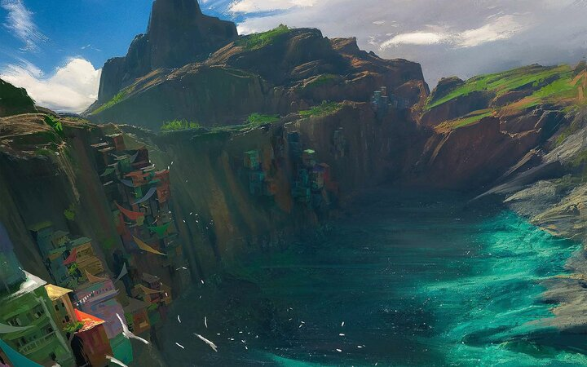

# General description

The old harbor is a place bustling with activity. It's always full of noise: the shouts of fishermen auctioning their fish, the loud thuds of crates being loaded off the boats, the cries of hungry seagulls. <Not authorized to access link> is located at the heart of the harbor.

In <Not authorized to access link>, <Not authorized to access link> reaches the harbor after surviving a shipwreck and being rescued by a fisherman.

...

## Inspiration

<https://www.youtube.com/watch?v=t0AmfPQMs4k>

# Levels that use this area

* <Not authorized to access link>
* <Not authorized to access link>
* ...

# Connections to other areas

* <Not authorized to access link> is located in the old harbor area.
* The old harbor is to the south of <Not authorized to access link>.
* ...